Meet the Post-Adoption Services Team
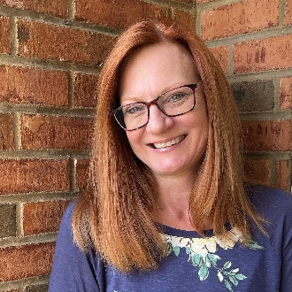 | Becky Sellers is an adoption specialist in the Christiansburg office. She has been with DePaul for over twenty years, serving first as a foster and adoptive parent and then as a community-based clinician. Becky is passionate about supporting families in their adoption journey. Becky enjoys connecting families to resources in their community and offering support and education to provide hope and healing to families and children. Outside of work, Becky enjoys spending time with her family, reading, focusing on health and fitness, and drinking vanilla lattes.
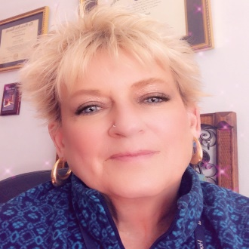 | Cindy Goldstein, MSW, has over 25 years of experience providing services to youth and families. She is based in the Roanoke DePaul office and serves adoptive families in the Piedmont landscape. Cindy is passionate about empowering families during their adoption journeys.
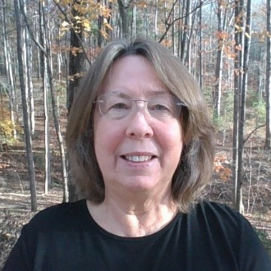 | Janice Monroe is a post-adoption specialist with Commonwealth Catholic Charities (CCC) covering the Piedmont regions of Lynchburg and the counties of Bedford, Campbell, Appomattox, and Charlotte. Janice has been with CCC for almost three years and has more than 11 years of experience working with children and families. Janice relies on her extensive training to ensure services are grounded in evidence-based practice and are delivered through a trauma-informed lens.
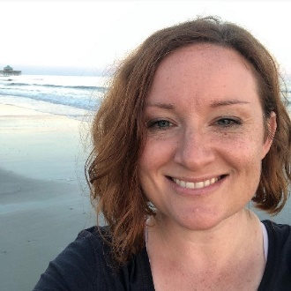 | Johnna Wilson provides post-adoption support through Commonwealth Catholic Charities and serves families throughout the Piedmont region of Virginia. Johnna has several years of experience in international adoption which has given her the ability to understand the unique needs of transracial and transcultural issues that families experience post adoption. Johnna is also a recently certified Grief Recovery Method Specialist.
 | Matthew Ball is a post-adoption specialist with Commonwealth Catholic Charities with over 10 years of experience in the field. He has worked for a residential treatment facility for adolescent boys, for the Department of Social Services in foster care and adoption, and as an intensive in-home family counselor. Matthew enjoys serving families and children in the foster and adoption communities and helping them navigate adoption specific challenges.
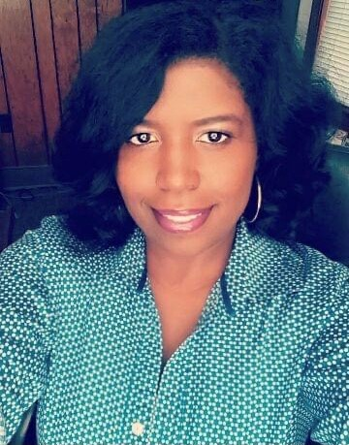 | Maxine Petty, MA, has been with DePaul Community Resources for over 5 years and is currently servicing the Piedmont region. Maxine has extensive knowledge and specializes in the importance of bridging the gap on cultural awareness and sensitivity regarding transracial adoptions. Maxine prefers to take a “How can we make it better” approach with foster/adoptive families to ensure that everyone’s needs are effectively and properly being met.
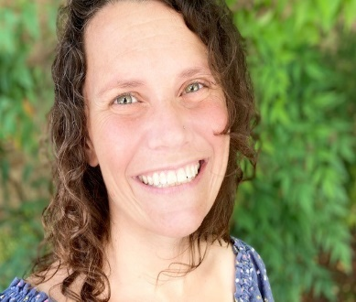 | Melissa Blau, LCSW, is honored to serve as the post-adoption regional coordinator. Melissa is passionate about supporting children and families and advocating for access to the services they need to recognize their limitless potential. Prior to coming to DePaul, Melissa provided crisis and outpatient counseling services. Her work consistently focuses on the importance of human connection, as she firmly believes that safe relationships provide the foundation for healing.
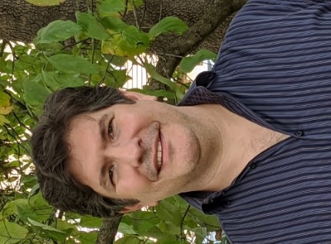 | Omar Ott joined the DePaul team in 2020 and brought with him a wealth of experience in delivering post-adoption services to families in the Piedmont region. Throughout his 20 years of service, Omar has gained an in-depth understanding of the unique challenges that adoptive families face and has a proven track record when it comes to working with parents and children to effectively navigate issues of attachment, trauma, grief, and loss.
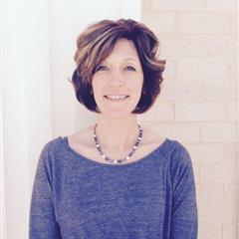 | Shannon Shepherd is an Adoption Specialist and Supervisor located in our Abingdon office. Shannon has been with DePaul for seven years and has been providing services to adoptive families for six of those years. Prior to coming to DePaul, Shannon spent 14 years working at a local DSS in Child Protective Services and Foster Care. In addition to have over 20 years of experience, Shannon herself grew up in foster care and was later adopted as a young adult. Shannon is passionate about helping youth and families and immensely enjoys the work she does.
 | Taylor Mills, MSW, is the post adoption supervisor for Commonwealth Catholic Charities overseeing CCC staff in the Piedmont and Western Regions. Taylor has been with CCC for six years, with experience in grant management for post adoption services and experience in providing therapeutic foster care services to children and families. Taylor’s main goal is to assure families are receiving quality services and support CCC post adoptive case managers in their work with families.
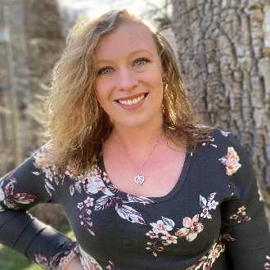 | Tonya Muncy, LMSW, is a post adoption specialist with DePaul Community Resources serving adoptive families in Tazewell, Bland, Wythe, Grayson, and Carroll counties. Tonya has 6 years of experience working with foster/adoptive families and has specialized training in delivering services in rural communities. Tonya recognizes each family’s unique adoption journey and is a fierce advocate for adoptive families. Tonya relies on her knowledge of trauma-informed care and adoption competency to partner with families to navigate the unique challenges that adoptive families face.

